**1 INTRODUCTION**

**1.1 Project Profile**

|  |  |
| --- | --- |
| **Project Title** | Stock Price Prediction using Machine Learning |
| **Project category** | Web Application |
| **Objective** | To Predict the stock price based on the past and upcoming events. |
| **Front End** | Django |
| **Back End** | Django, Python |
| **Tool** | Anaconda, Google Colab |
| **Server** | XAMP |
| **Documentation Tool** | Office 365 |
| **Company Name** | MADHDA BUSINESS SOLUTIONS PVT LTD |
| **Internal Guide** | Dr. Jigneshkumar A. Chauhan |
| **External Guide** |  |
| **Developed By** | Preyash Sanjay KaPatel (1803421003) |
| **Group No** | 19 |

**1.2 About the Organization / Company**

Company provides a complete solution with high performance with helping hand from startup level to the enterprise level.

We provide Microsoft Dynamics ERP solutions to our clients worldwide. We work closely to provide consulting, maintenance, Implementation support, Upgrades, Re-architect to our client. To make your company and products smarter are more successful.

* We provide custom solution to our client.
* An employee is the most valuable asset for an organization.
* We design, implement and manage your Microsoft Dynamic ERP.
* We utilize our expertise in providing sustainable enterprise solutions to customers and help their businesses maximize potential.
* For us every business is built on good relation with client.
* The leaders at Madhda about their employees’ well-being, happiness and success.
* We are driven by a set of guiding principles which dictate our decisions and responsibilities towards our people and customers.
* To provide businesses with the ERP software and knowledge they need to succeed in a competitive market.
* We conduct business ethically.
* We embrace positive change, innovation, and continuous improvement.
* In return our employees feel recognised and appreciated for their contributions to the company.

**2 SYSTEM STUDY AND ANALYSIS**

**2.1 Problem Statement**

The Stock market check is an exceptionally fascinating errand which joins high substances of how the budgetary exchange limits, and what unconventionalities can be prompted in a market in light of different conditions. While a few venders may battle that the market itself is functional, and that if there is new check or any assortment from the standard in a market it charms it by auditing itself, thusly making no space for conjectures, while several vendors may battle that on the off chance that the information is orchestrated well, by then machine can make a sort out of procedure that is persuading can affect high continue exchanging or HFT, which is just conceivable through Machine Learning Algorithm.

Money related authorities think about the expression, buy low, move high yet this does not give enough setting to settle on proper endeavor decisions. Before an investigator places asset into any stock, He should realize how money markets continues. Setting assets into a wonderful stock regardless at a horrible time can have awful results, while vitality for a common stock at the fortunate time can hold up under focal points. Cash related monetary pros of today are going toward this issue of trading as they don't for the most part understand concerning which stocks to buy or which stocks to offer with the authentic objective to get impeccable focal points. Envisioning whole game plan estimation of the stock is commonly clear than foreseeing on day-to-day premise as the stocks change rapidly reliably subject to world events.

The answer for this issue requests the utilization of instruments and advances identified with the field of information mining, design acknowledgment, machine learning and information forecast. The application will foresee the stock costs for the following exchanging day. The necessities and the usefulness of this application corresponds it to the class.

**2.2 Existing System**

The existing system works as follow:

* Money related transaction require high alertness of statistical insights of history and future events, in such case taking decision of stake sale, hold or buy are difficult.
* Before taking decision, we need to look at the past data, stock patterns, Recent news and judging the price takes time and it might end up in slow decision, incomplete information etc.
* Taking the Stake sale/buy/Hold based on emotion and incomplete information may perform false prediction.

**2.2.1 Drawbacks**

Following are the main drawbacks of existing system:

* Incomplete Information
* Emotion based Decision
* Unawareness of stock price patterns

**2.3 Proposed System**

**2.3.1 Advantages / Comparison Study**

1. Rapid Decision:
   1. User can take decision rapidly as it is performed autonomous.
2. Improved Accuracy:
   1. User can use the result to take decision for stake sale or hold or buy
3. Based on Historic data:
   1. Prediction are based on historic data and past events.

**2.3.2 Modules (with short description)**

1. Login:
   1. Admin and Account Holder can access website by successfully login
2. Watchlist:
   1. User can add remove stock from watchlist.
3. Holdings:
   1. Here user can see there stock holding if they have.
4. Predictions:
   1. In this module user can predict the stock price.

**3 DEVELOPMENT ENVIRONMENT**

**3.1 Hardware Requirement**

* Client Side:
  + Hardware Requirement:
  + Basic CPU with 700 MHz Speed
  + 1 GB RAM
* Server Side:
  + Inter i3 10th generation
  + GB RAM
  + 250 mb Space in SSD

**3.2 Software Requirement**

* Client Side:
  + Chrome with 68.0.3440.75 or above Version
  + Good Internet Speed
* Server Side:
  + Chrome with 68.0.3440.75 or above Version
  + High Speed Internet
  + Google Colab
  + Webpage IDE
  + Github Desktop

**3.3 Programming Environment**

**3.3.1 About Front-End**

* Java Script
* HTML
* Django Framework

**3.3.2 About Back-End**

* Python
* PyCharm
* Jupyter Notebook
* Microsoft Excel
* SQL
* Yahoo Finance
* Tensorflow
* Keras
* Sklearn
* Stock Market Live API
* Django

**4 SYSTEM DESIGN AND DEVELOPMENT**

**4.1 Data Dictionary**

**Name: DataModel**

**DESCRIPTION:- Represents stock holding and watchlist Primary Key: id**

|  |  |  |  |  |
| --- | --- | --- | --- | --- |
| **Sr.No** | **Field Name** | **Data Type** | **Constraint** | **Description** |
| 1 | id | IntegerField | Primary Key | Represent Record id |
| 2 | user | ForeignKey | ForeignKey | Represent registered User |
| 3 | avgCost | FloatField | Not Null | Represent Average cose |
| 4 | created | DateTimeField | Not Null | Represent stock addition date and time |
| 5 | price | FloatField | Not Null | Represent last updated price |
| 6 | qty | IntegerField | Not Null | Represent quenty |
| 7 | symbol | CharField | Not Null | Represent stock symbol |

**Name: User**

**DESCRIPTION:- Represents users’s details Primary Key: id**

|  |  |  |  |  |
| --- | --- | --- | --- | --- |
| **Sr.No** | **Field Name** | **Data Type** | **Constraint** | **Description** |
| 1 | id | IntegerField | Primary Key | Represent user id |
| 2 | Date_joined | DateTimeField | Not Null | Represent date of joining |
| 3 | email | EmailField | Not Null | Represent Email id of user |
| 4 | First_name | CharField | Not Null | Represent First Name |
| 5 | Is_active | BooleanField | Not Null | Represent user status |
| 6 | Is_staff | BooleanField | Not Null | Represent user is staff member or not |
| 7 | Is_superuser | BooleanField | Not Null | Represent user is super user or not |
| 8 | last_login | DateTimeField | Not Null | Represent last login date and time |
| 9 | last_name | CharField | Not Null | Represent user’s last name |
| 10 | Password | CharField | Not Null | Represent password |
| 11 | username | CharField | Not Null | Represent username |

**4.2 User Modeling Language Diagrams**

**4.2.1 Use Case Diagrams**

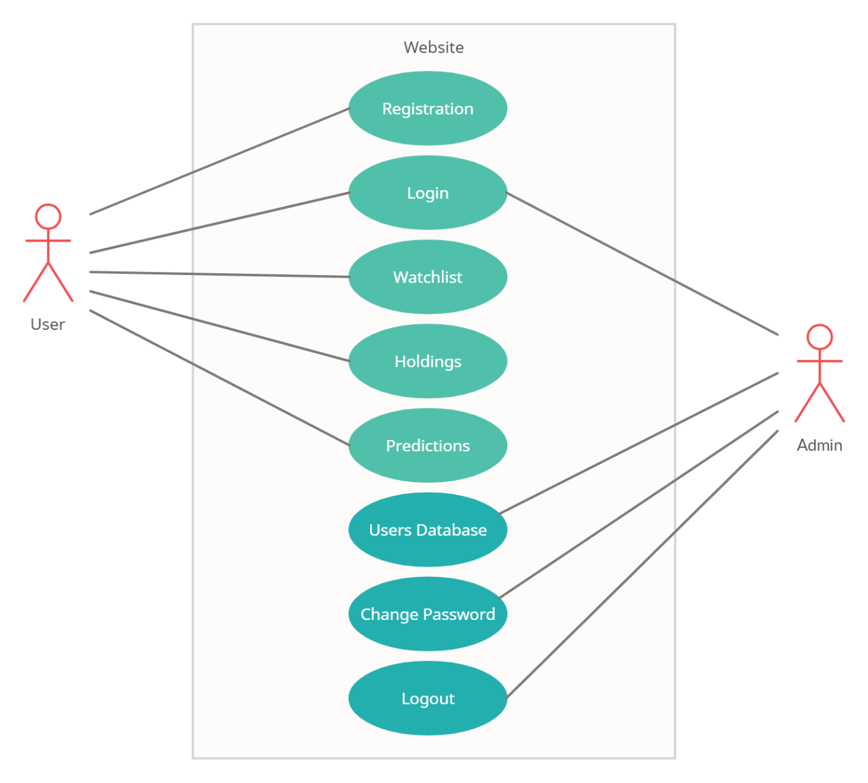

**4.4.2 Activity Diagrams**

**Activity Diagram for User**

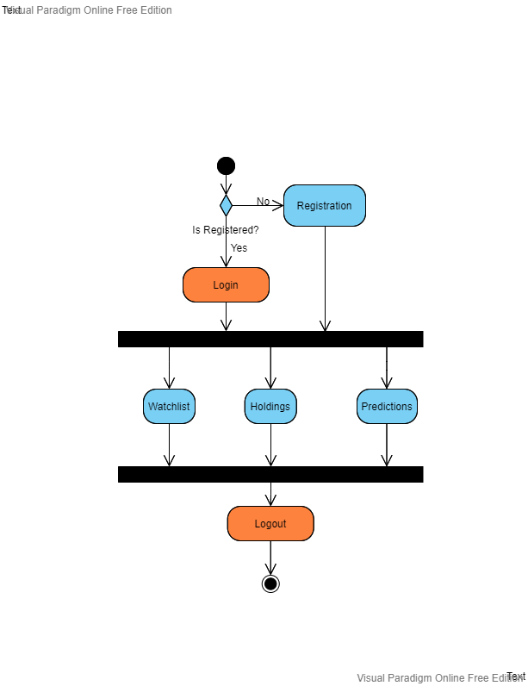

**Activity Diagram for Admin**

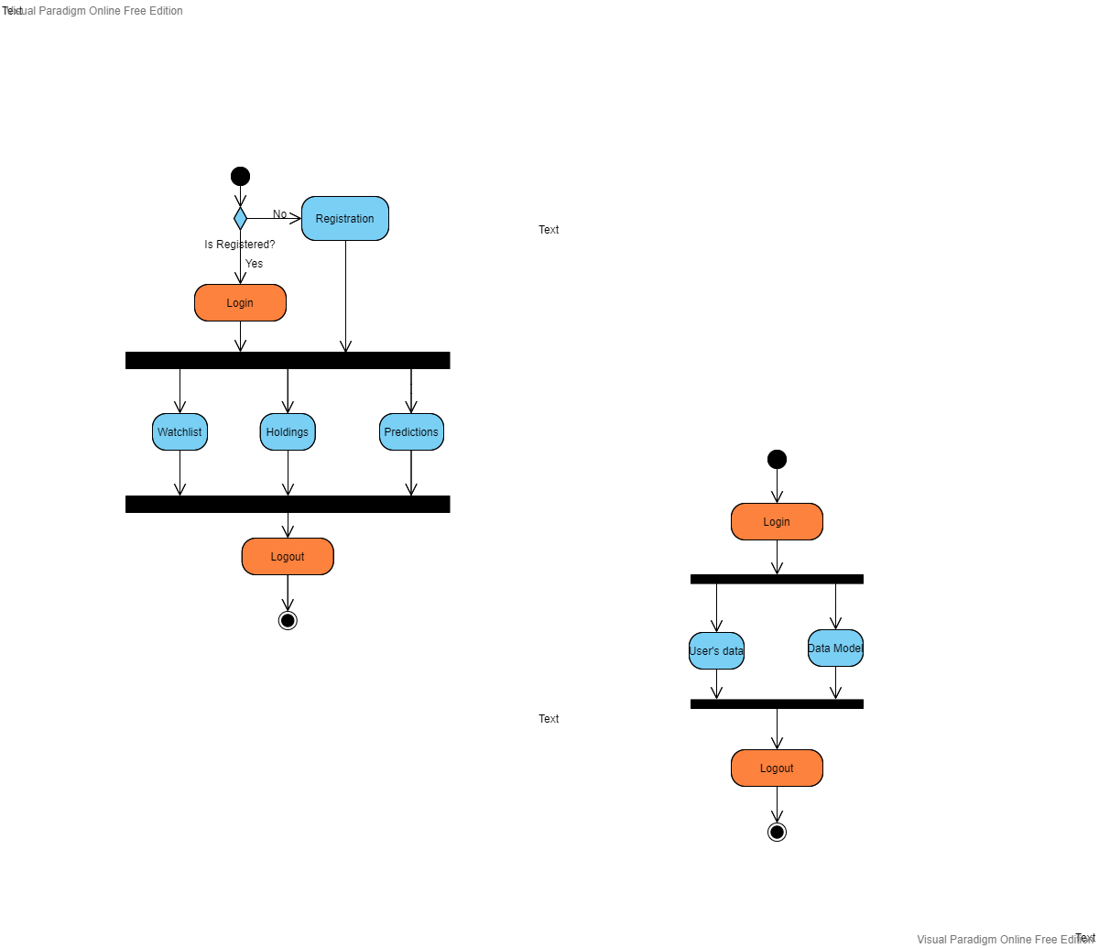

**4.4.3 Sequence Diagrams**

**Sequence Diagram for User**

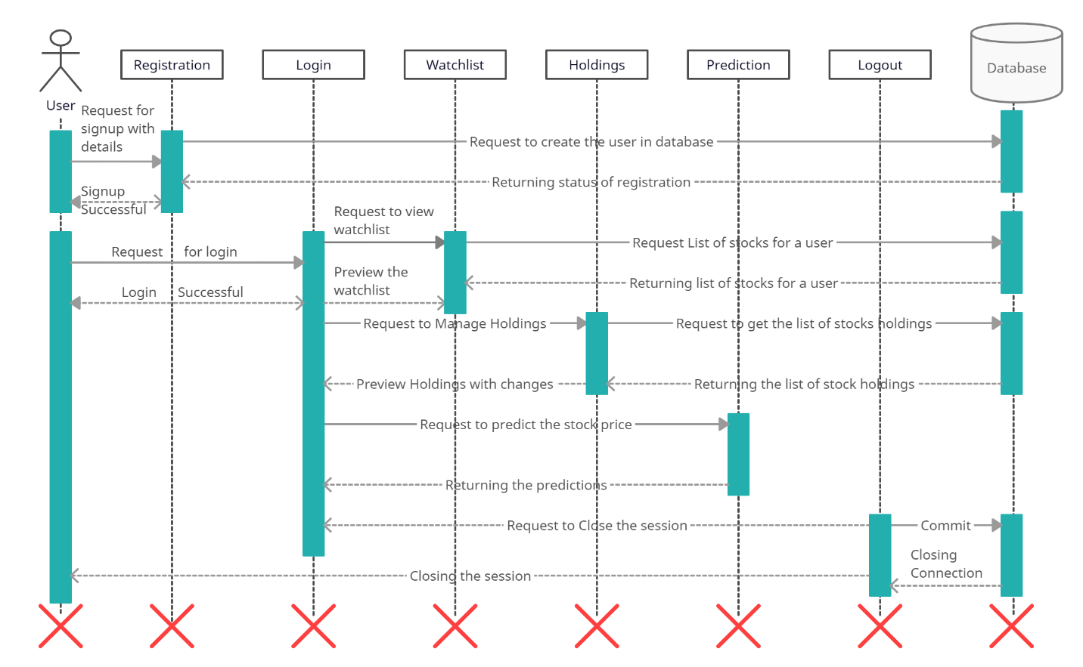

**Sequence Diagram for Admin**

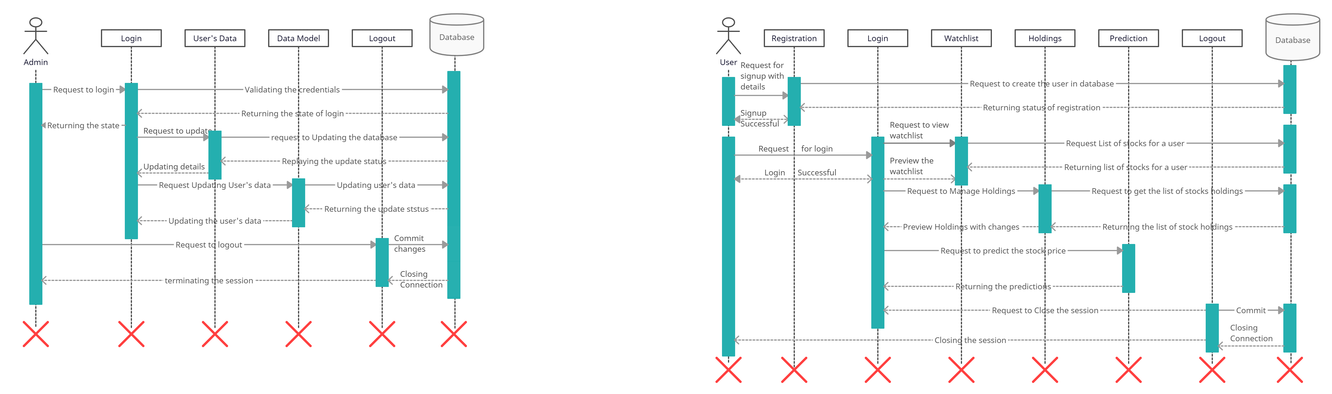

**4.4.4 Class Diagrams**

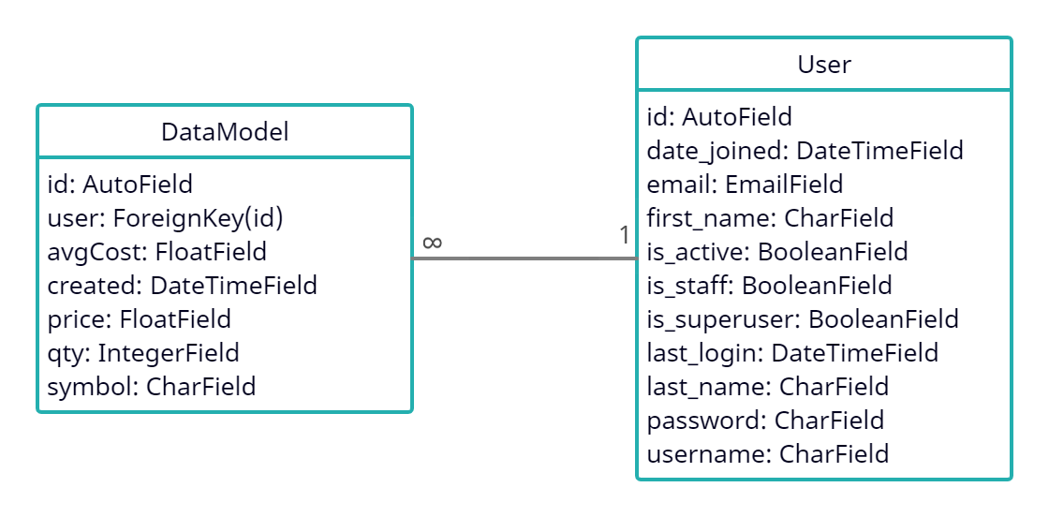

**4.5 Input Design**

**Login Page:**

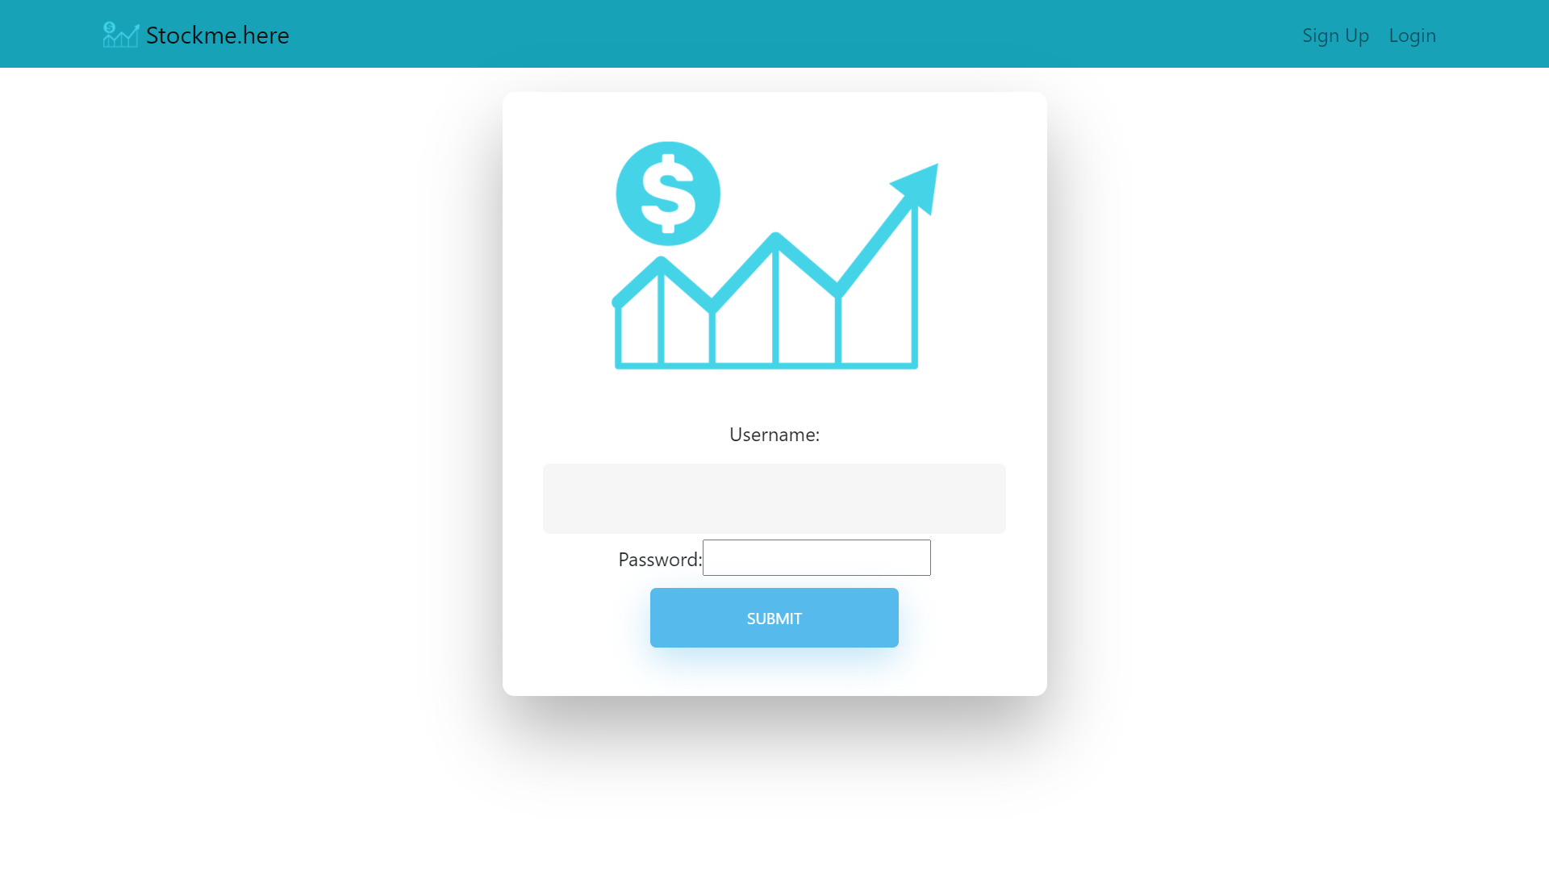

**Signup Page:**

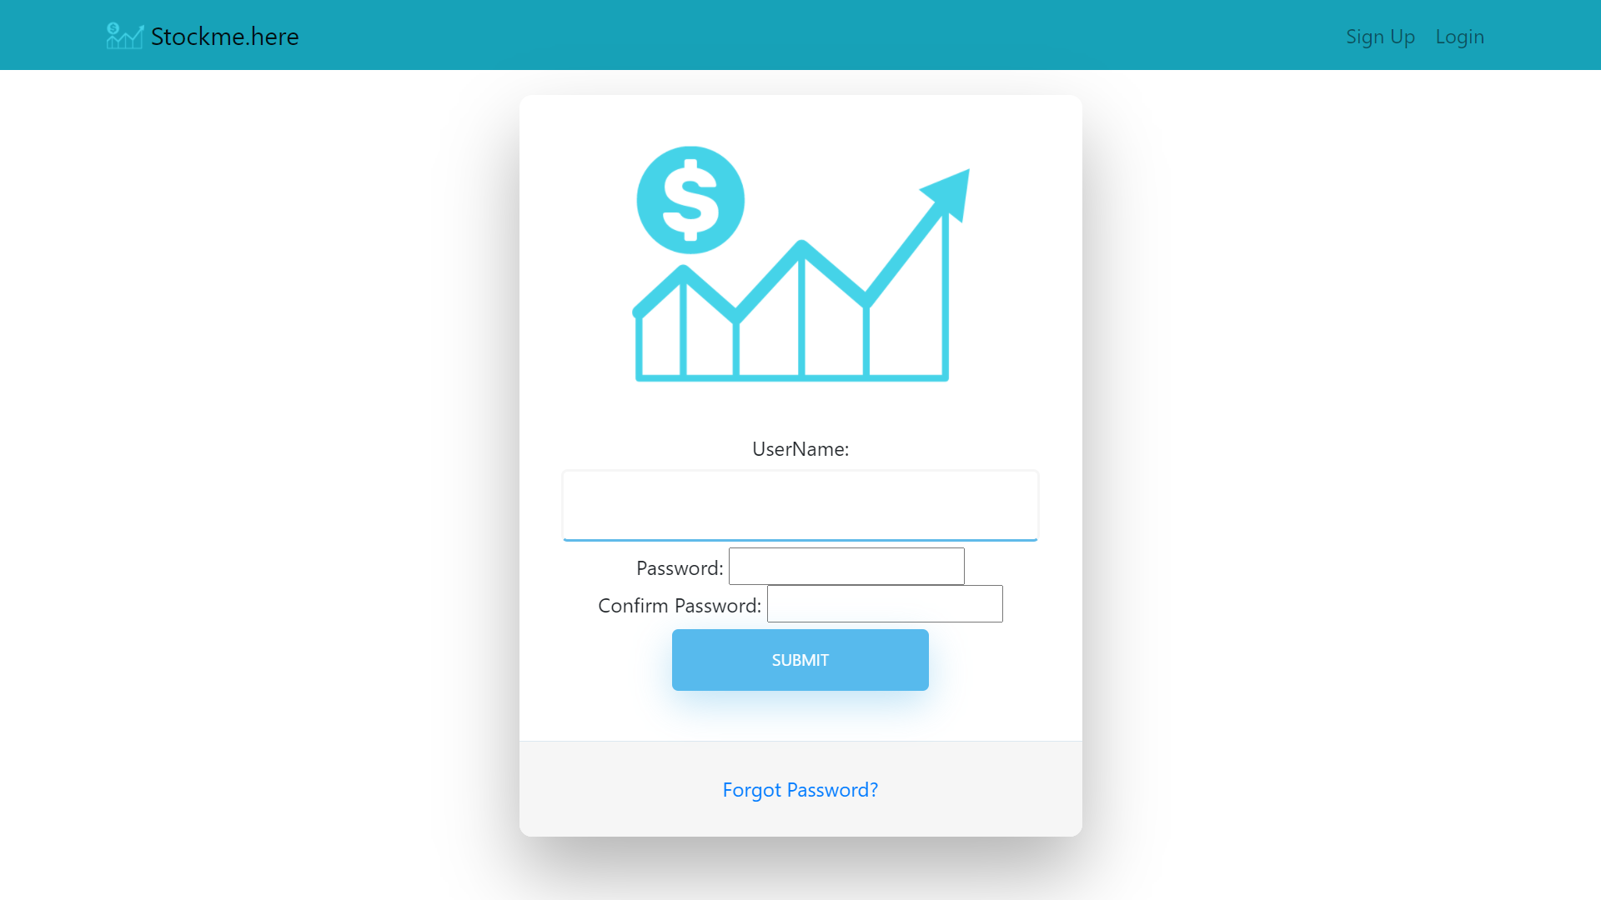

**Watchlist Page**

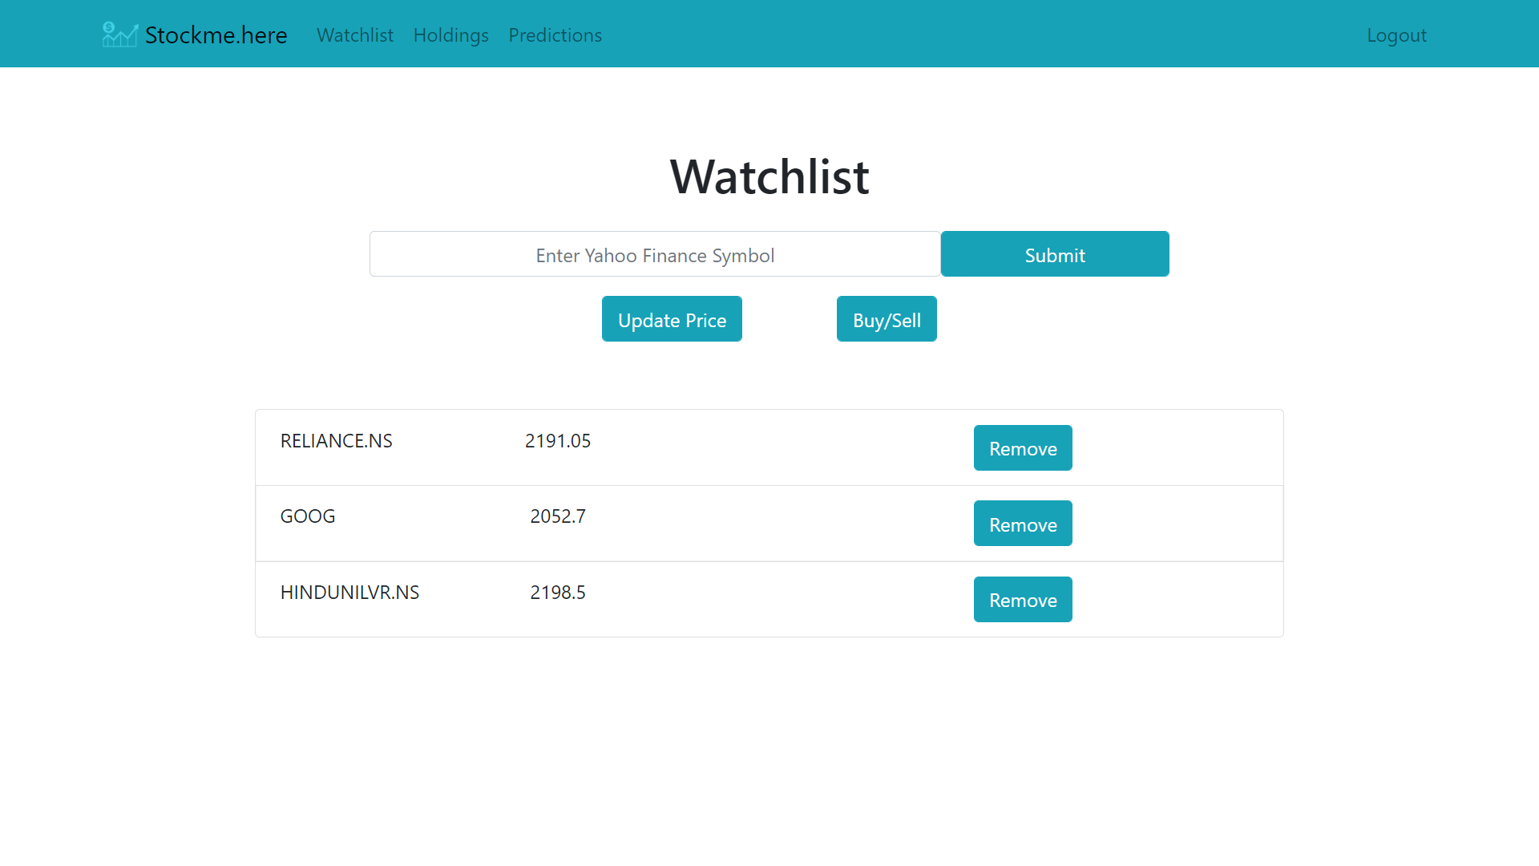

**Holdings Page**

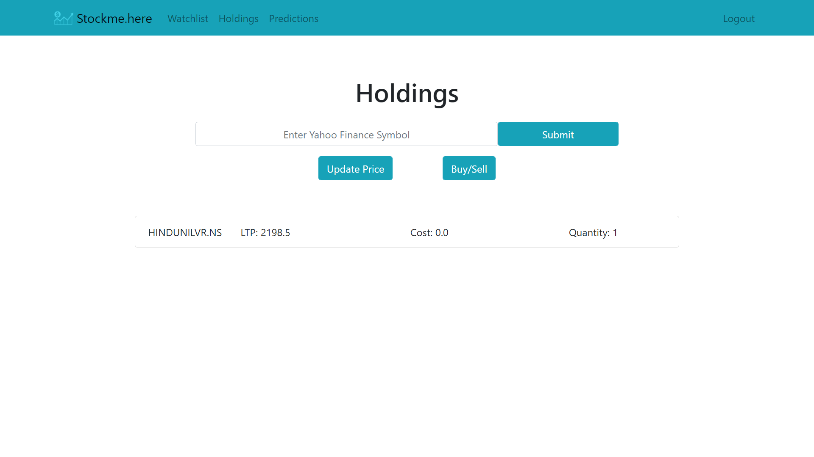

**Prediction Page**

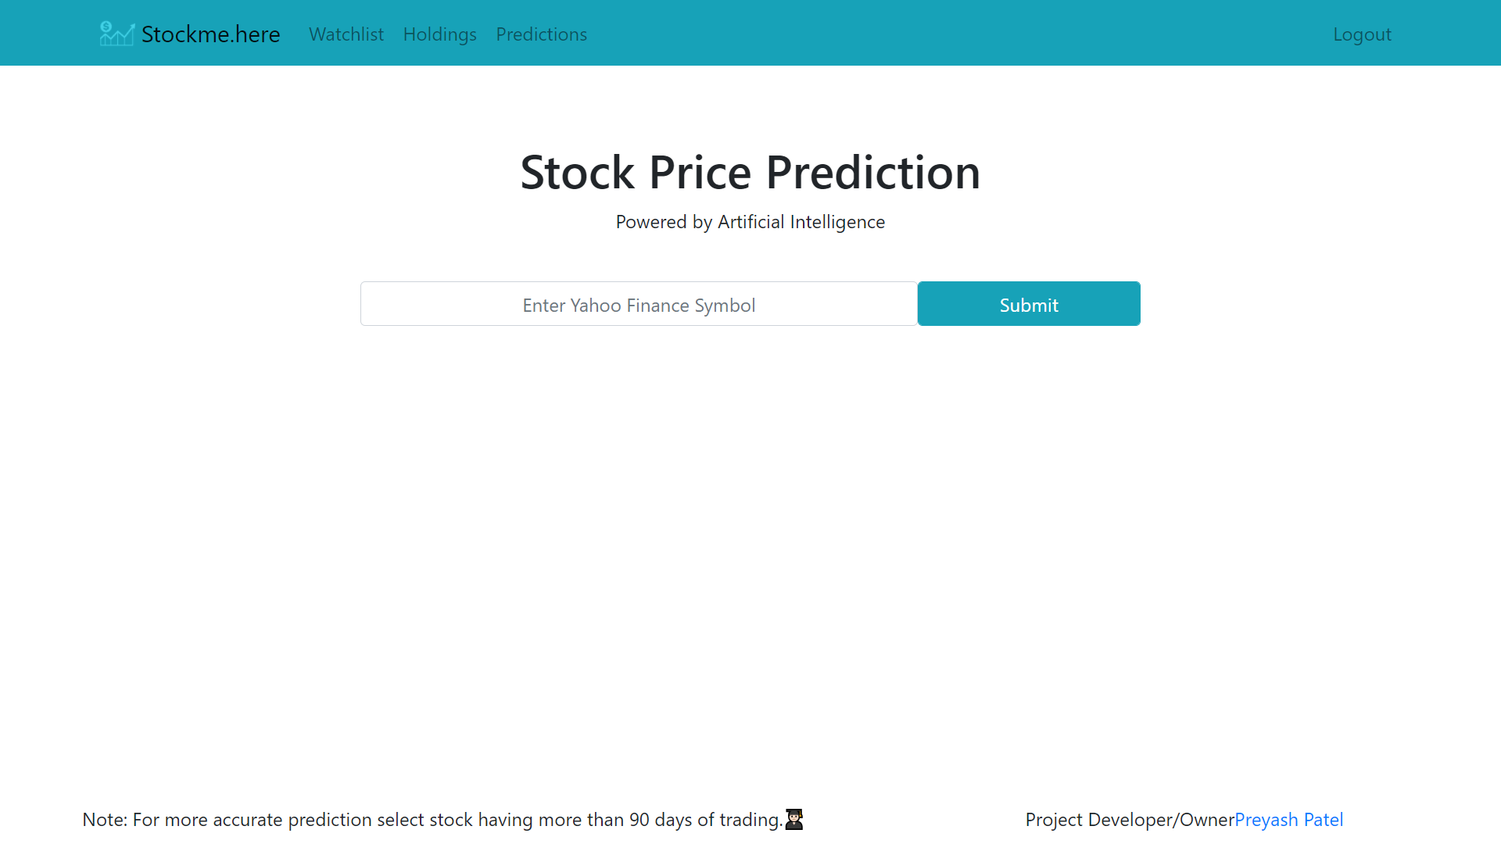

**4.6 Output Design**

**Prediction Page**

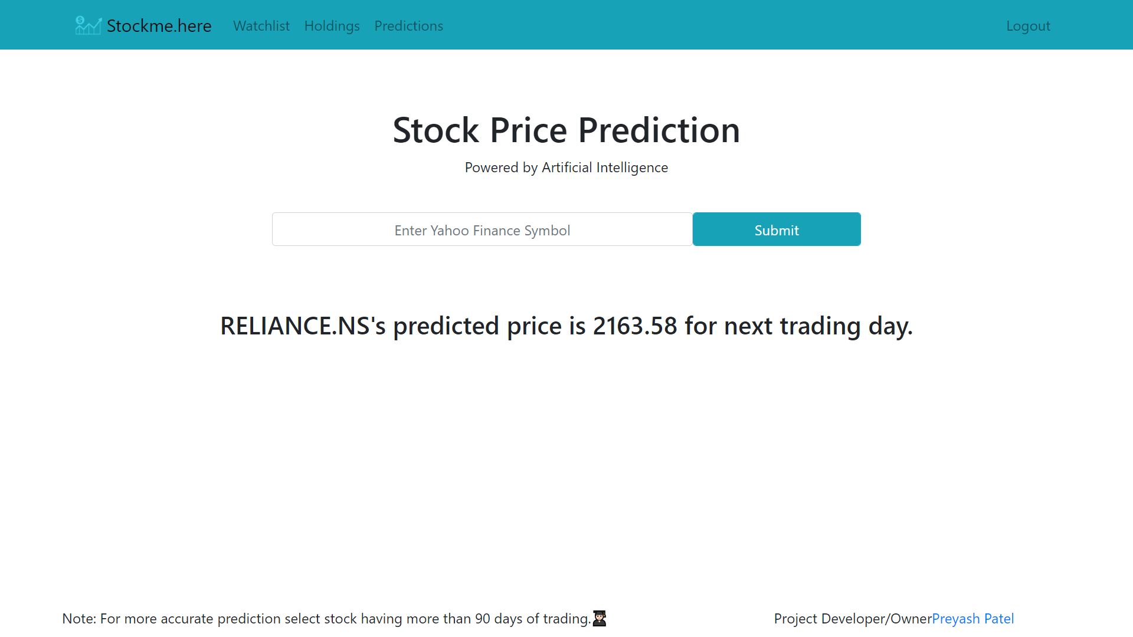

**Home Page**

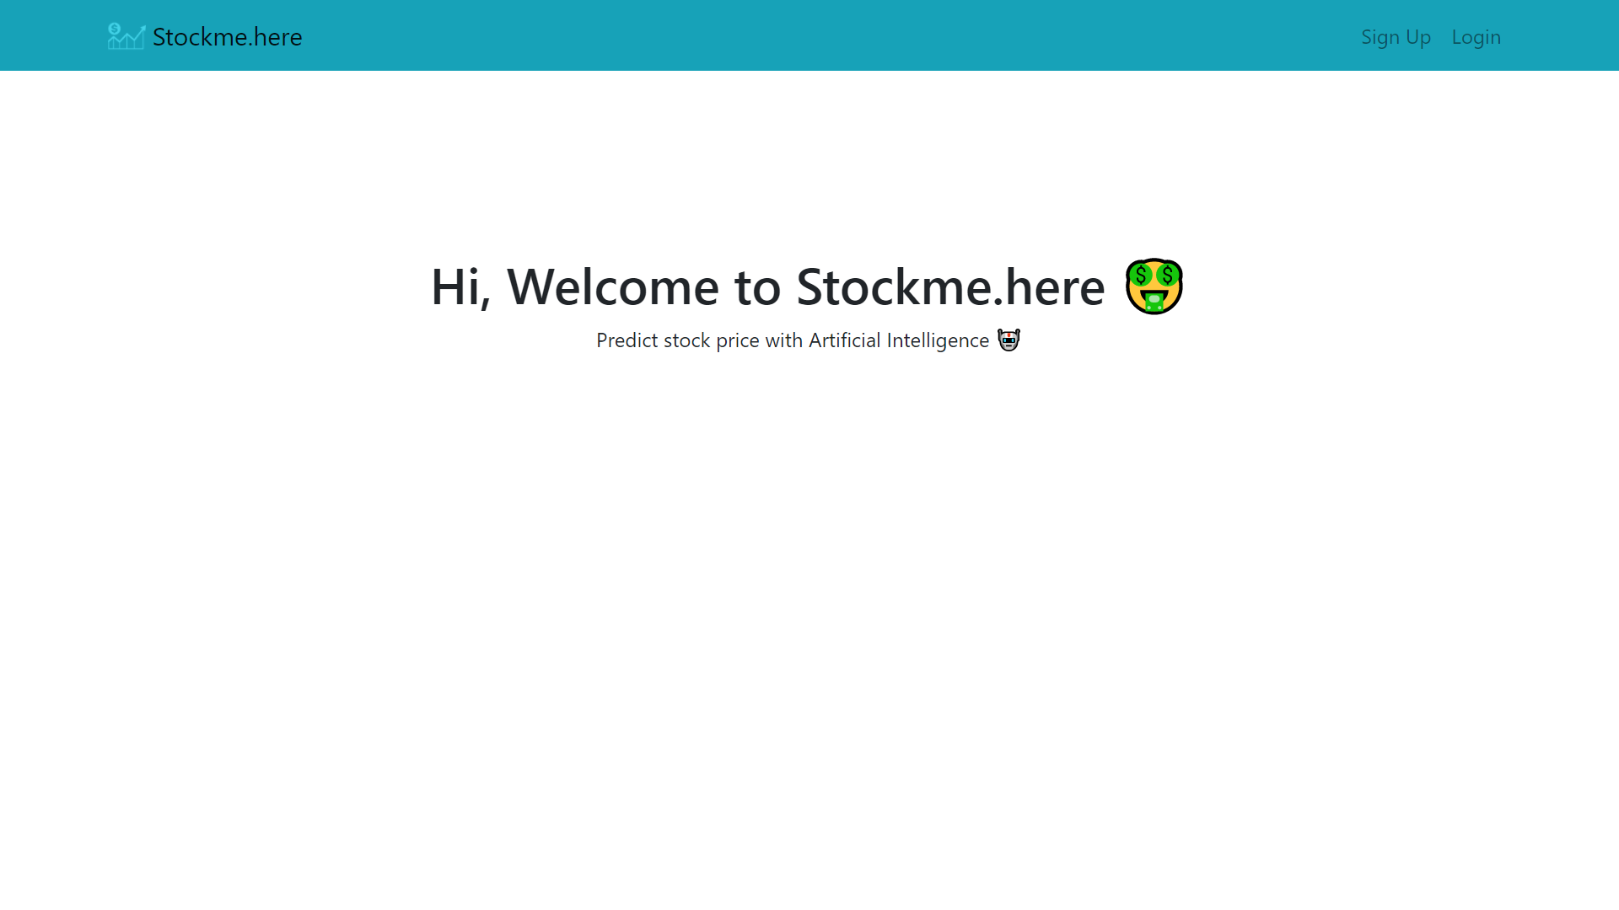

**Home after login**

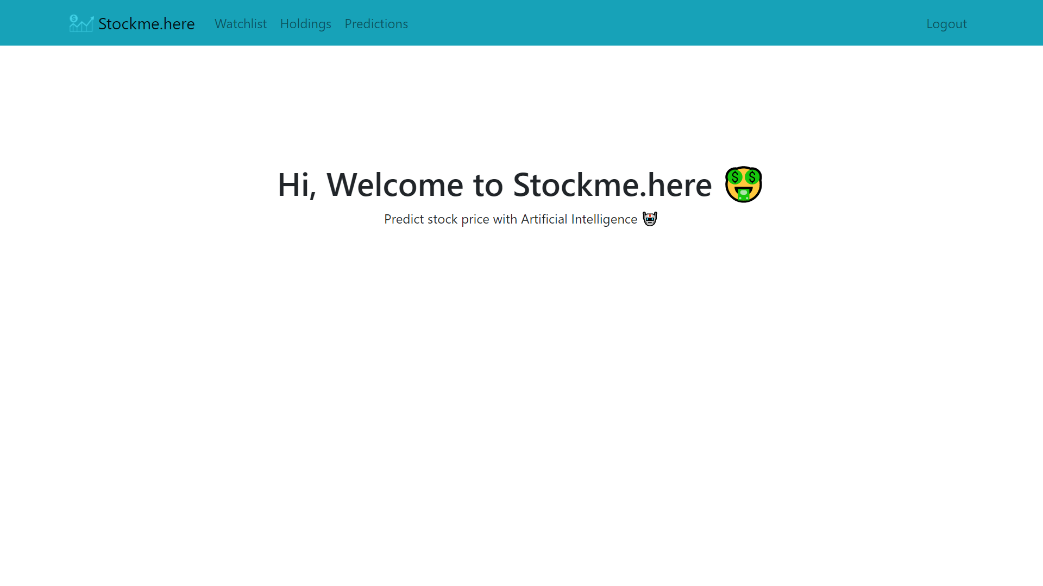

**5 SYSTEM TETSTING**

**5.1 System Testing**

**5.1.1 Output Testing**

**5.1.2 Validation Testing**

**Testing For Login/Signup Validation**

|  |  |  |  |
| --- | --- | --- | --- |
| Sr.No | Validation Checking | Excepted Result | Test Result |
| 1 | Usename | Not Null and Unique | Pass |
| 2 | Password | Not null | Pass |
| 3 | Confirm Password | Not null | Pass |

**Testing For Watchlist**

|  |  |  |  |
| --- | --- | --- | --- |
| Sr.No | Validation Checking | Excepted Result | Test Result |
| 1 | Symbol | As per Yahoo Finance | Pass |

**Testing For Holding**

|  |  |  |  |
| --- | --- | --- | --- |
| Sr.No | Validation Checking | Excepted Result | Test Result |
| 1 | Symbol | As per Yahoo Finance | Pass |
| 2 | Quantity | Greater then Zero | Pass |

**Testing For Prediction**

|  |  |  |  |
| --- | --- | --- | --- |
| Sr.No | Validation Checking | Excepted Result | Test Result |
| 1 | Symbol | As per Yahoo Finance | Pass |

**6 CONCLUSION AND FUTURE ENHANCEMENT**

**6.1 Conclusion**

Hereby, it can be proposed that no trading algorithm can be 100% effective, not only 100%, it will typically never be close to 70% but to attain even an accuracy of 40% or 35% is still good sufficient to get a good forecast spread. Although extreme attained accurateness was 39%, it was still able to closely forecast the predictable outcome and have coordinated against the company graph. To make our expectation more efficient, it can be done by including bulky data sets that have millions of entries and could train the machine more powerfully. Different activities of stocks can lead to diverse raises or lows in the forecast price, use these movements to magistrate whether a company should be traded in or not. No training Data can ever be stable, hence there are always some unevenness which can be seen in the above data spread, but to still forecast close to an consequence will also lead to a good approach if it has greater than 33% accuracy. While, developing a strategy trader should always think to always have nominal imbalance while still being above 33%accurate.

It can also be determined that in a stock market, there is probable that some companies might not be associated at all, and mostly can be associated to each other, and can help justice movements of stock accordingly, we can scale affairs and see how much in percentages they are correlated.

Including gigantic data sets, to increase more effectiveness, and in data set if had nan values in tables, because of two simple reasons either a specific company wasn’t opened during that time of year, or the data is not readily obtainable, in both the cases replace the null values with 0, which is somewhat that trader might want to change while developing a trading tactic.

Furthermore, there can be back testing of the trading strategy, using zip line and quantopian a python platform for testing trading strategies and can see how well can a model fit into some random data of stock, and can the model from this random data of stock develop relations and correlations, and predict on terms of change.

**6.2 Future Enhancements**

* Implement NLTK to have impact of News on Stock Price Prediction
* Speeding up the Model training time
* Maintain prebuilt model for faster response
* News update for respective stock
* Stock’s Fundamentals view

**7 BIBILIOGRAPHY & REFERENCES**

**7.1 Books References**

* Hands-On Machine Learning with Scikit-Learn, Keras, and TensorFlow: Concepts, Tools, and Techniques to Build Intelligent Systems
* Python Machine Learning

**7.2 Web References**

* <https://www.djangoproject.com/>
* https://in.finance.yahoo.com/
* <https://www.python.org/>
* http://tensorflow.org/
* http://keras.io/

NOTE:-

* Fonts should be remain constant “times new roman”, size 12 , throughout the report.
* However titles and subtitles can have different size.
* Also set proper margin

# PHYSICAL (LAYOUT) DETAILS

Paper size: A4

Margins: Left – 1.5”, Right – 1”, Top – 1”, Bottom – 0.5”

Page No: At the center of the bottom (footer); format: – m –

Font: Times New Roman

Chapter headings: 15” Bold, Upper case

Main headings: 13” Bold & Underlined, Upper case

Sub headings: 12” Bold, Title case

Sub-sub headings: 12” Bold & Italics, Title case

Table, Fig. Nos: 12” Italics, Title case

**Format for data-dictionary:**

No, Fieldname, Field type, Field size, Constraint, Control name, Description

**With Screen-shot of Database structure & records**

**Format for bibliography:**

Authors, “Title”, (year), Publisher / publication, Price (if available)

**Some of the topics may not be applicable to some of the projects in that case you can ignore some content or you can add as per the requirement and guidance of your project guide.**